The future of computer games?
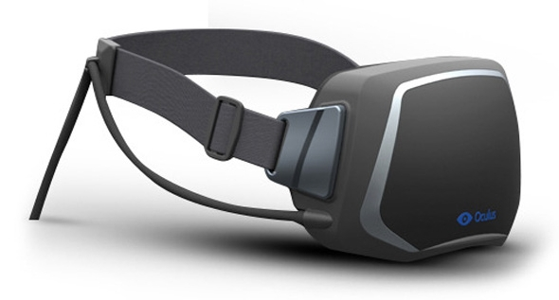

The Facebook owned Oculus Rift is the first of a next generation of Virtual Reality headsets based on technology made cheap enough because of the popularity of smart phones, could become the future of all computer gaming.

Oculus VR have made some special development kits which are for computer game makers to use to help make new games. Some industry experts think that a second development kit may be announced as soon as late March at the Game Developers Conference.

With the Occulus Rift you will be able to play many new computer games such as Left 4 Dead, Half-Life 2, Portal 2, Skyrim, Mirror’s Edge, Unreal Tournament 3, Dear Esther and DiRT2.

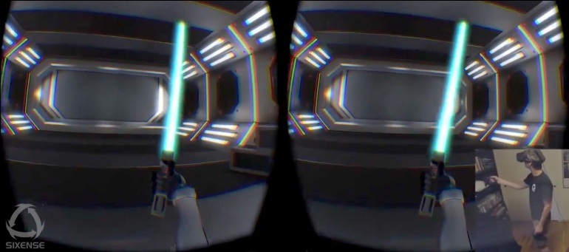
People can connect the Occulus Rift to their computer or games console and play games standing up or sitting down. People who have used the headset say that a short demo game to show how the headset will work felt as though they were in another world. Also that the game can become part of your reality because your subconscious mind can become involved in the virtual reality as well as your conscious mind.
You can wear your own headphones and it has special lenses in case you need to wear glasses.
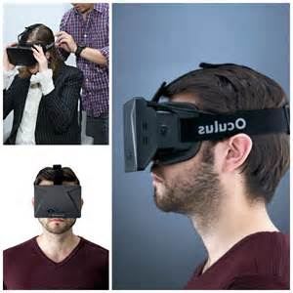
The final version for everyone may be a year away and there are many improvements that will need to be made before it is ready for the consumer market. Nobody is certain about the price, but people think it will cost about 250 to 300 US dollars.
True, false or not given?
1. Facebook own Oculus Rift.
2. Facebook paid one billion dollars to buy Oculus rift.
3. Oculus Rift owes its development to smart phone technology.
4. You can play computer games standing up with it.
5. People who used the Oculus Rift felt that they were in another world.
6. Some people who played games with it felt sick.
7. The Oculus Rift is finished and ready.
8. Many people think it will cost less than $300.

1. True
2. Not Given
3. True
4. True
5. True
6. Not given
7. False
8. True
Discussion
- Would you like to try or buy an Oculus Rift?
- How do you think it would make you feel?
- What do you think your parents would think about it?
- Do you think it's cheap or expensive?

