Imagine you are going on your dream holiday. Discuss the following:

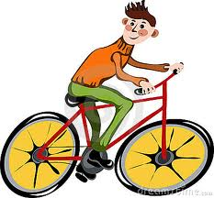
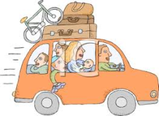
- What means of transport would you use?
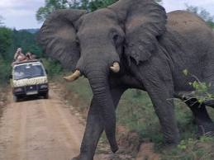
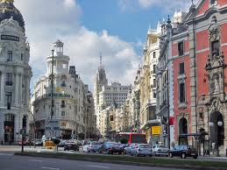
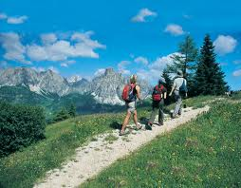
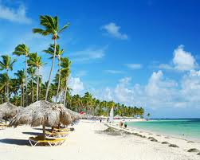
- Where would you go?

- Who would you go with?

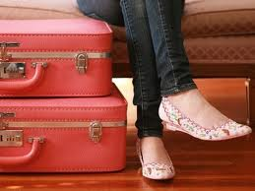
- What would you take with you?

Write about your dream holiday:
…………………………………………………………………………………………………………………………………………………………………………………………………………………………………………………………………………………………………………………………………………………………………………………………………………………………………………………………………………………………………………………………………………………………………………………………………………………………………………………………………………………………………………………………………………………………………………………………………………………………………………………………………………………………………………………………………………………………………………………………………………………………………………………………………………………………………………………………………………………………………………………………………………………………………………………………………………………………………………………………………………………………………………………………………………………………………………………………………………………………………………………………………………………………………………………………………………………………………………………………………………………………………………………………………………………………………………………………………………………………………………………………………………………………………………………………………………………………………………………………………………………………………………………………………………………………………………………………………………………………………………………………………………………………………………………………………………………………………………………………………………………………………………………………………………………………………………………………………………………………………………………………………………………………………………………………………………………………………………………………………………..……….

