Men and Women
- Introductory questions

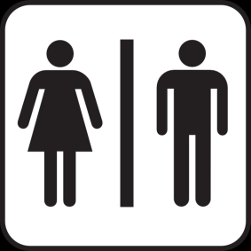
- How are men and women different?
- Are you very manly / womanly?
- What are men and women better at?
- Have men and women changed over the past 100 years? In what ways?
- What do you look for in your would be spouse? What physical and personality traits?
- What’s important to you?

- Rank the items from 1 to 3 within each group (1 = least important, 3 = most important).

A B C
___ intelligence ___ romantic person ___ long-term relationship
___ looks ___ sincere person ___ having kids
___ personality ___ common interests ___ wait and see

- Compare your answers with a partner.
- Quotes
Read the following quotes with your partner. For each one decide:
- What does it mean?
You know you're in love when you can't fall asleep because reality is finally better than your dreams. –
Dr. Seuss
Lots of people want to ride with you in the limo, but what you want is someone who will take the bus with you when the limo breaks down. - Oprah Winfrey
- Do you agree with it?
- Why or why not?

At the touch of love, everyone becomes a poet. - Plato

Life is a flower of which love is the honey.
- Victor Hugo
You call it madness, but I call it love. -Don Byas
Better to have loved and lost, than to have never loved at all." - St. Augustine

- Categories

Good qualities in a partner | Bad qualities in a partner | Places to go on a date | Things to eat on a date | Good gifts for a partner

