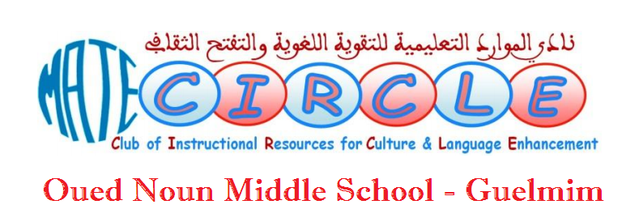

MATE CIRCLE PERIOD 2 ACTION PLAN
(February 16th through April 27th, 2018)
School: Oued Noun Middle School | Delegation: Guelmim | Academy: Guelmim Oued Noun
Coordinator: Mohamed Lahbib KATHI | Email: funkathi@gmail.com | Tel: +2126…………………

P.2 | Date | Focus Areas |  | Specifications |  | Focus Themes
S 1 | 16 February, 2018 | Welcome Back  &  Creative Writing |  | - Welcoming new sts.  - Reflections  - Create & Communicate |  | - Period 1 evaluation  - Rules & updates  - Self-portraits & autobiographical poems
S 2 | 23 February, 2018 | Project Work 1 |  | Mr. Chef |  | - Food and Drinks
S 3 | 02 March, 2018 | Performing Arts 1 |  | Acting 1 |  | - Role plays / Skits
S 4 | 09 March, 2018 | Reading 1 |  | - Short story reading and discussion |  | - Literature Circles
S 5 | 16 March, 2018 | Performing Arts 2 |  | - Acting 2 |  | - Rehearsals
S 6 | 23 March, 2018 | Fun Activites |  | Teachers for Global Classrooms
S 7 | 30 March, 2018 | Reading 2 |  | - Video clip viewing (song) and discussion
S 8 | 06 April, 2018 | Project Work 2 |  | - Handicraft |  | - Environment
Spring Holiday (April 8th through April 15th, 2018)
S 9 | 20 April, 2018 | Rehearsals for the party
S 10 | 27 April, 2018 | Party
S 11 | Project work: Reading circles. |  | Throughout period 1 |  | Different stories
S 12 | Cultural Exchanges |  | Throughout period 1 |  | Exchanging projects with other students overseas.
S 13 | Publications: online postings. |  | Throughout period 1
S 14 | Contests and Shows |  | Throughout period 1 |  | - Preliminaries of Regional Reading Contest March 25th.  - Talent Show Contest
S 15 | MATE CIRCLEs Local Festival
