Gender stereotypes
Discuss if you agree with the following statements:

- A woman should take care of her family while a man should earn money.

- Men don’t cry.

- If a woman/man is 30 and single, she is a failure.

- A man should propose to a woman. It’s unnatural for a woman to ask a man to marry her.

- Women who don’t wear high heels are unfeminine.

- A man should carry a heavy bag for a woman.

- Women don’t shake hands.

- “Women are nothing but machines for producing children.”

- “A woman needs a man like a fish needs a bicycle.”

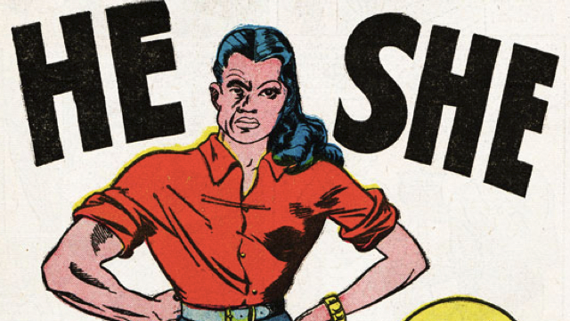

Gender stereotypes
Discuss if you agree with the following statements:

- A woman should take care of her family while a man should earn money.

- Men don’t cry.

- If a woman/man is 30 and single, she is a failure.

- A man should propose to a woman. It’s unnatural for a woman to ask a man to marry her.

- Women who don’t wear high heels are unfeminine.

- A man should carry a heavy bag for a woman.

- Women don’t shake hands.

- “Women are nothing but machines for producing children.”

- “A woman needs a man like a fish needs a bicycle.”

