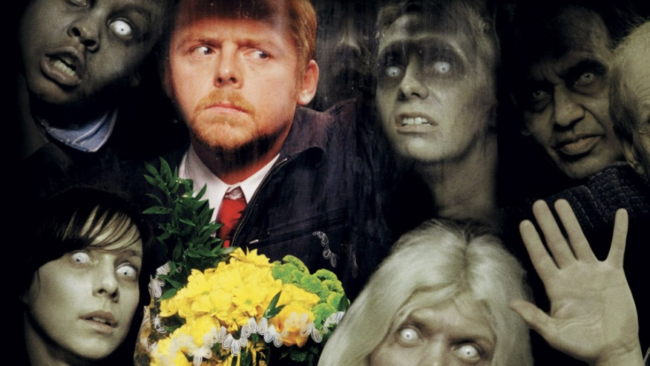
It’s the Zombie Apocalypse! Something catastrophic has happened and you 3 are the only survivors. You are in the building, surrounded by zombies. You need to find a way to survive.
Do you stay together? Split up? Do you stay here or leave the building?
Make a plan to survive this and find other survivors. You don’t need to worry about water or food- you can loot the stores since there are no more laws!
You may choose 4 items to help you on your journey:
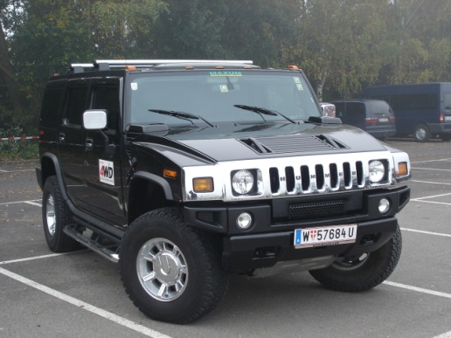  A Hummer with ¼ tank of gas | 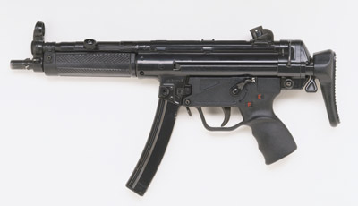  A machine gun (loaded with 250 bullets) | 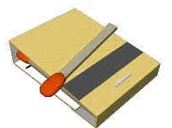  A book of matches
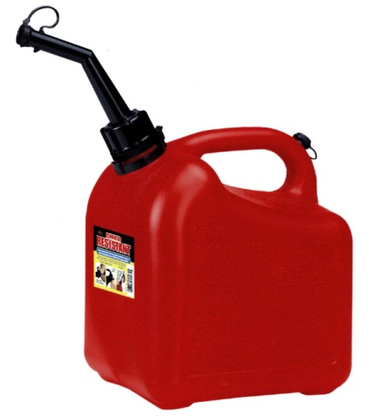  10 gallons of gasoline | 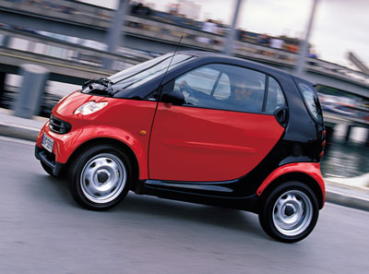  A Smart car (2 seats, electric) | 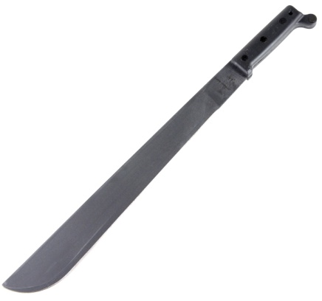  A machete
Dog | 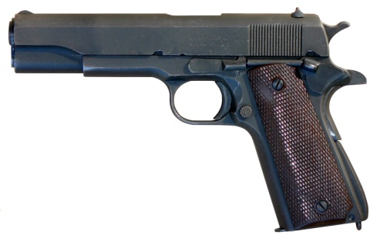  Pistol (loaded with 15 bullets) | 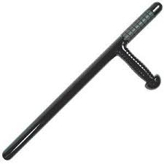  Police baton
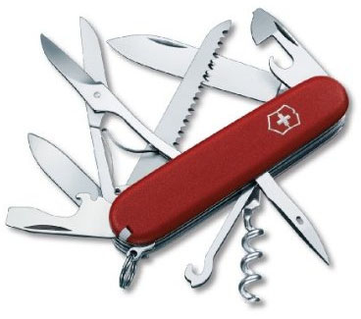  A Swiss Army Knife | 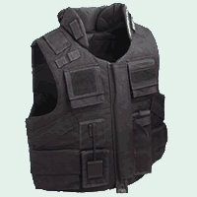  Bullet proof vest | 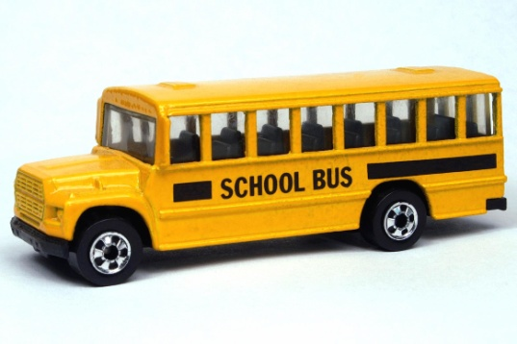  A School bus with ½ tank of gas
Horse | 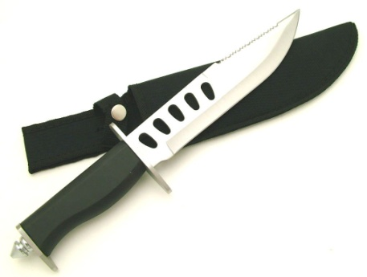  Hunting knife | 1 object of your choice

