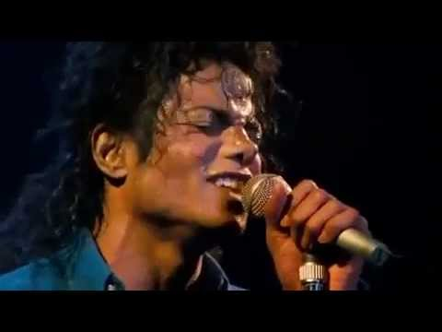
(Michael Jackson)
http://www.youtube.com/watch?v=ZLgD6V1Qg8w
- Listen to the song and fill in the blanks:

I'm gonna make a _____________,  for once in my _____________  It's gonna feel real ____________  gonna make a diference  Gonna make it _______________.  As I, turn up the collar on  my favorite winter ____________  This wind is blowing my mind  I see the ___________ in the streets,  with not enough to _____________  Who am I to be ______________?  Pretending not to see their needs  A summer disregard,a broken__________ top  And a one man soul  They follow each other on the__________ ya' know  'Cause they got nowhere to ___________  That's why I want you to know  I'm starting with the man in the ____________  I'm asking him to change his ways  And no message could have been any clearer  If you wanna make the___________ a better place  Take a look at yourself, and then make a change  (Na na na, na na na, na na, na na)  I've been a victim of a selfish kind of love  It's time that I realize  That there are some with no __________, not a ______________ to loan  Could it be really me, pretending that they're not alone?  A willow deeply scarred, somebody's _________________  And a washed-out dream  They follow the pattern of the wind ya' see  'Cause they got no place to ___________  That's why I'm starting with ___________ | CHORUS 3 X  (You gotta get it right, while you got the time)  ('Cause when you close your heart)  You can't close your... your mind!  That man, that man, that man, that man  That man, that man, that man,  You know... that man  No message could have been any clearer  If you wanna make the world a better place  (If you wanna make the world a better place)  Take a look at yourself and then make the change  Hoo! Hoo! Hoo! Hoo! Hoo!  Na na na, na na na, na na, na nah  (Ooooh...) Oh no, no no...  I'm gonna make a change  It's gonna feel real ____________!  Come on! (Change...)  Just lift yourself  You know  You've got to stop it, Yourself!  (Yeah! - Make that change!)  I've got to make that change, today! Hoo!  (Man in the mirror)  You got to  You got to not let yourself...brother ! Hoo!  You know - I've got to get  that man, that man...  You've got to  You've got to move! Come on! Come on!  You got to...  Stand up! Stand up! _______________!  Stand up and lift yourself, now!  (Man in the mirror)  You know it! You know it! You know it! You know it...  (Change...)  Make that ______________.
- Answer the questions:
- While watching the video, you could notice some famous personalities in there. Do you know them? Can you name some?
________________________________________________________________
- What did these people do to make the world a better place?

- Martin Luther King:
- Gandhi:
- Mother Teresa of Calcuta:
- John Kennedy:
- Ronald Reagan and Gorbachov:

- What is the change the singer wants to make?
- When he says “gonna make it right,” what does “it” mean?
I'm gonna make a change,
for once in my life
It's gonna feel real good,
gonna make a difference
gonna make it right . . .
- Who are “the kids”?
- Who is the “man in the mirror”?
- What kind of change do you think he will make?
I'm starting with the man in the mirror
I'm asking him to change his ways
And no message could have been any clearer, if you wanna make the world a better place
take a look at yourself, and then make a change
- What is a “selfish love”?
- What does he mean when he says, “not a nickel to loan”?
I've been a victim of a selfish kind of love
It's time that I realize that there are some with no home, not a nickel to loan
could it be really me, pretending that they're not alone?
- What does he mean when he says, “starting with me”?
That's why I'm starting with me
- Do you agree with these lyrics? Why? What does he mean when he says these lyrics?
If you wanna make the world a better place
Take a look at yourself and then make that . . .change!
- What is “it”?
You've got to stop it. Yourself!
Discuss with your partner and then tell the class.
- What do you think of the song? Do you like it? Why or why not?
- Do you think you can “make that change” and have a great life? Why or why not?
- What is the most important change that you want to make in your life? Explain.
- What can you do to make the world a better place?

