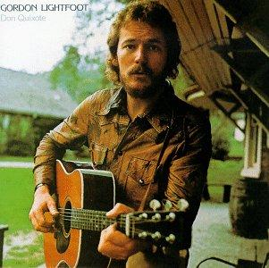
Gordon Lightfoot
Sundown
Part 1: Fill In The Blank
I can _____ _____ lyin' back in her ______ dress
In a ______ where ya do what ya ______ confess.

Part 2, Chorus x 2:
Sundown ya better take care
If I find you been ________'round my back stairs.

Part 3: Choose The Word
always sailor's queen means feelin' shame
She's been lookin' like a __________ in a __________ dream
And she don't __________ say what she really ____________
Sometimes I think it's a _________
When I get ________ better when I'm feelin' no pain x2

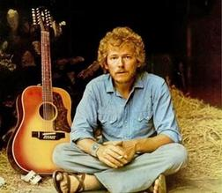

think , shame
fast , faded
feelin', no pain
lovin' , feelin'
Part 5, Choose The Word Pairs

I can see her lookin' ________ in her ________ jeans
She's a hard ________ woman, got me ________ mean
Sometimes I _________ it's a _________
When I get ________ better when I'm feelin' _________

Part 4, Matching:
I can picture every move it's a sin
Getting lost in her lovin' better take care
Sundown ya that a man could make
If I find you been creepin' when I'm losin' again
Sometimes I think is your first mistake
When I feel like I'm winnin' 'round my back stairs

Sample Discussion Questions:

1. Some women are attracted to "bad boys," and some men to "bad girls." Why?
2. If you were treated badly by your lover, but you were crazy about them, would you stay or go?
3. What does it take for you to break-up with someone?
4. Have your or a friend had a relationship where alcoholism caused a break-up?
5. Do you believe dating someone "too attractive" can be a negative?
6. Have you ever suspected your boy/girlfriend was cheating on you? Did you learn the truth?

